**Assignment (20 marks)**

* This is a group assignment. MUST have 3 - 4 students in a group.
* All members MUST be from the same Tutorial group.
* One of the group members MUST be assigned as a leader to manage the work and report participation percentages of each member.
* The due date for the assignment is on 27 .03. 2022, by 11.59 PM.
* You MUST submit your assignment in **softcopy** (App + Documentation).
* Any plagiarism is not tolerated, all assignments will be checked using **Turnitin.**
* For this assignment you MUST develop web application using HTML as front end (can include JavaScript and others)
* Using different programming languages such as C++, Java or VB will result in ZERO mark.
* Late Submission: 5 marks will be deducted per day.
* Absent for presentation: result in ZERO mark for the whole project.

**Implement ONE application with the following functions**

1. Convert Regular grammars into NFA (as a formal definition with transition table)

Includes the following sub functions

* 1. Testing strings (up to 5 strings at once) a statement to inform user whether each string can be generated by the RG.
  2. Convert -NFA [into an NFA](http://www.chegg.com/homework-help/questions-and-answers/convert-following-nfa-equivalent-dfa-q3704362) without -transitions (if any)
  3. Draw the NFA (optional)

1. Convert NFA (transition table) into Regular grammars

Includes the following sub functions

* 1. Testing strings (up to 5 strings at once) a statement to inform user whether each string is accepted or rejected NFA.
  2. Draw the NFA (optional)

**Important: Final App must look like the examples below : ONE application with one Main HTML file to start with. POP-UPS SCREENS AND MESSAGES ARE NOT ALLOWED .**

Example :

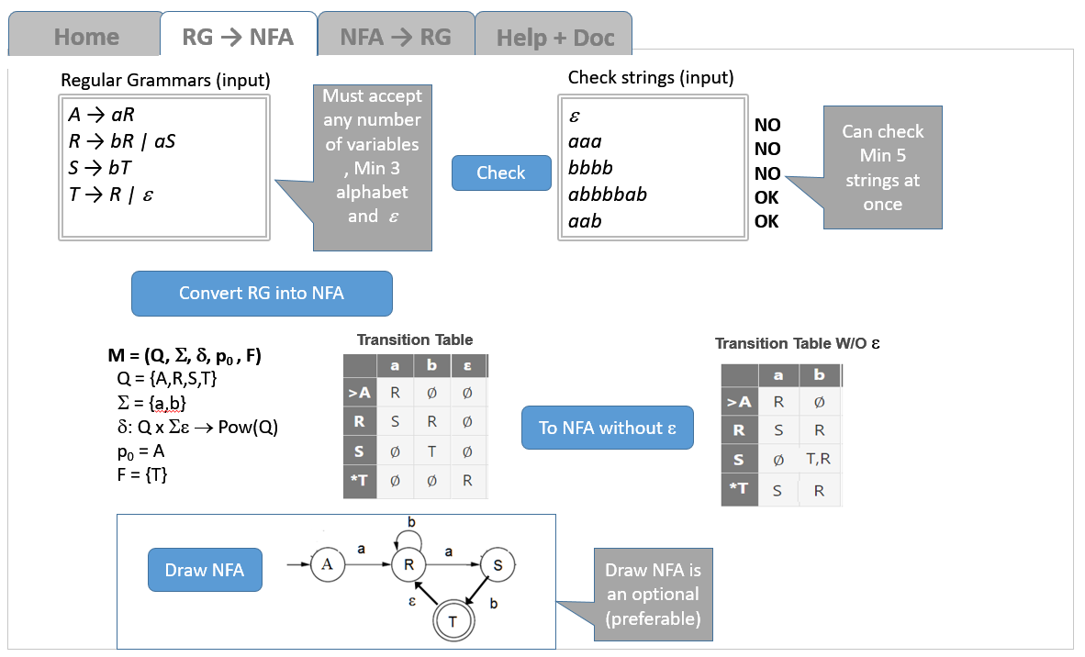

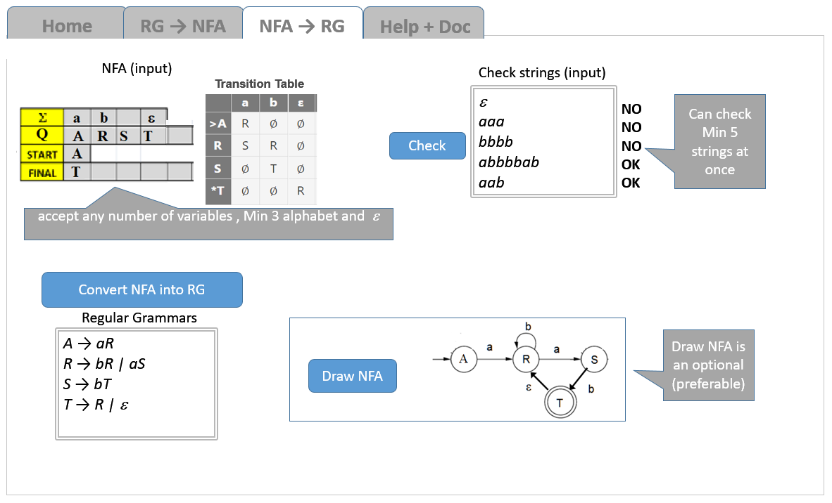

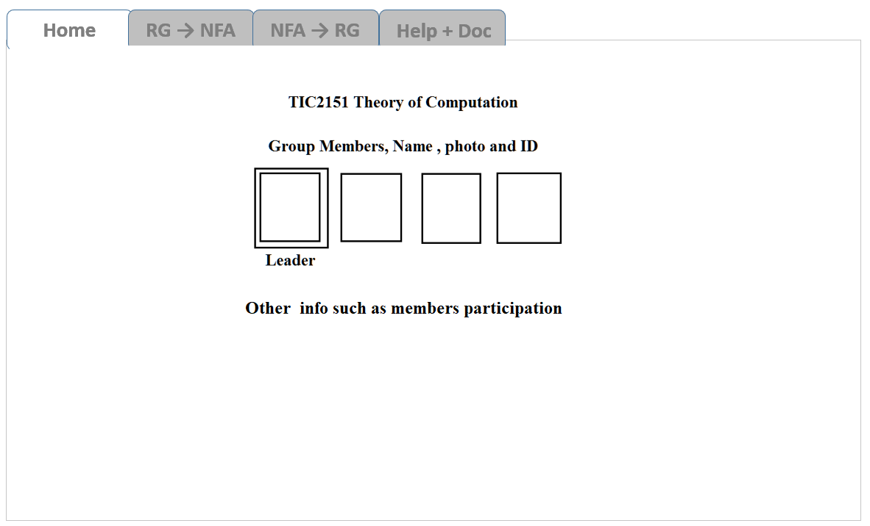

**Your submitted project must include a Main file (main.html) to start with, main page must not be used to run other programs or take the user to another page, everything must be displayed within the main page.**

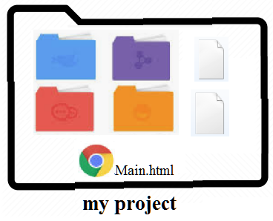

**Marks Distribution**

**Design 10 %**

**Functions: 60 %**

**Documentation + Presentation : 30 %**

**Documents must include:**

1. Cover page
2. Members and their participation percentages
3. Introduction
4. Design Flowcharts ,
5. 4 screenshots
6. Manual with examples
7. Problems and limitations:
8. Important codes